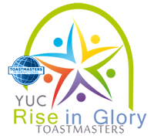
Yanbu University College
Students Activities
Toastmasters International
Rise in Glory
Vote Counter Report
Meeting: Date: Time:
Name: ID:

Prepared Speech
Name
Tally

Evaluators
Name
Tally

Table Topic
Name
Tally

